C610 SERIES STAINLESS STEEL CAPPED BEZEL
CAM LOCK

DESCRIPTIONS:  - Zinc alloy die cast housing and cylinder.  - Stainless steel capped bezel.  - Yellow die-chromate plated standard.  - 5 disc tumbler mechanism.  - Brass keys, nickel plated.  - Key may be withdrawn in one or both positions.  - 5 sizes available.  - Various cam configurations and rotations available.  - C610XS cam is fixed only, other size cam affixed by screw or fixed.  - Hex nut or speed clip mounted.  - 100 combinations available.  KEY-PULL FIGURES  -Indicates Key-Pull  -Indicates No Key-Pull  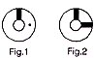 | 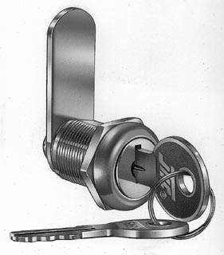

  SCREW FIXED
  Sizes
  XS | 11.1 | 18.5 | 14.8
  S | 15.9 | 23 | 19.2
  M | 22.2 | 29.1 | 
  L | 28.6 | 35.7 | 
  XL | 35 | 42 | 
  Fig. No. | Lock Number | Positions | Key Pulls | Turn
  1 | C610-1 | 2 | 1 | 90 
  2 | C610-2 | 2 | 2 | 90 

