C910
HIGH SECURITY CAM LOCK

DESCRIPTIONS:  - Brass housing and cylinder.  - Bright chrome plated standard.  - High security 14 pin tumbler mechanism.  - Steel made tubular keys, nickel plated, with plastic cover.  - Key may be withdrawn in one or both positions.  - Various cam configurations and rotations available.  - Cam is affixed by nut.  - Hex nut mounted.  - 10000 combinations available.  KEY-PULL FIGURES  -Indicates Key-Pull  -Indicates No Key-Pull  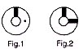 | 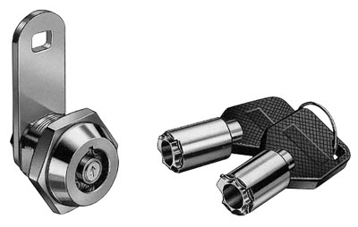

Fig. No. | Lock Number | Positions | Key Pulls | Turn
1 | C910-1 | 2 | 1 | 90 
2 | C910-2 | 2 | 2 | 90 

