C620
CAM LOCK

DESCRIPTIONS:  - . Zinc alloy die cast housing and cylinder.  - . Bright chrome plated standard.  - . 5 disc tumbler mechanism.  - . Brass keys, nickel plated.  - . Key may be withdrawn in one or both positions..  - . Various cam configurations and rotations available.  - . Cam is affixed by screw.  - . Hex nut or speed clip mounted.  - . 100 combinations available.  KEY-PULL FIGURES  -Indicates Key-Pull  -Indicates No Key-Pull  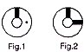 | 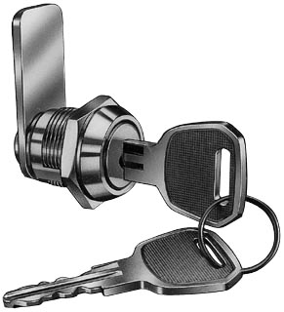

Fig. No. | Lock Number | Positions | Key Pulls | Turn
1 | C620-1 | 2 | 1 | 90 
1 | C620-2 | 2 | 2 | 90 

