C1091
CAM LOCK

DESCRIPTIONS:  - . Zinc alloy die cast housing and cylinder.  - . Bright chrome plated standard.  - . 4 disc tumbler mechanism.  - . Brass keys, nickel plated.  - . Key may be withdrawn in one or both positions..  - . Various cam configurations and rotations available.  - . Cam is affixed by screw.  - . Hex nut mounted.  - . 14 combinations available.  KEY-PULL FIGURES  -Indicates Key-Pull  -Indicates No Key-Pull  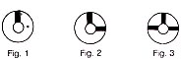 | 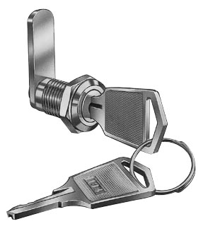

Fig. No. | Lock Number | Positions | Key Pulls | Turn
1 | C1091-1 | 2 | 1 | 90 
2 | C1091-2 | 2 | 2 | 90 
3 | C1091-3 | 3 | 3 | 180 

