C312
CAM LOCK

DESCRIPTIONS:  - Zinc alloy die cast housing and cylinder.  - Bright chrome plated standard.  - 3 disc tumbler mechanism.  - Brass keys, nickel plated.  - Key withdrawals in both positions only.  - Various cam configurations and rotations available.  - Cam is fixed.  - Speed clip mounted.  - 4 combinations available.  KEY-PULL FIGURES  -Indicates Key-Pull  -Indicates No Key-Pull  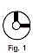 | 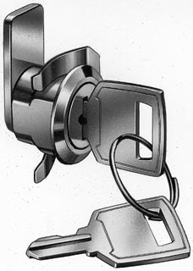

Fig. No. | Lock Number | Positions | Key Pulls | Turn
1 | C312-2 | 2 | 2 | 90 

