C628
LARGE FULL SIZE FLAT CAM LOCK

DESCRIPTIONS:  - Zinc alloy die cast housing and cylinder.  - Bright chrome plated standard.  - 5 disc tumbler mechanism.  - Reversible double-bitted brass keys, nickel plated,plastic cover.  - Key may be withdrawn in one or both positions.  - 2 sizes available.  - Various cam configurations and rotations available.  - Cam is affixed by screw.  - Hex nut or speed clip mounted.  - 100 combinations available.  KEY-PULL FIGURES  -Indicates Key-Pull  -Indicates No Key-Pull  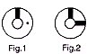 | 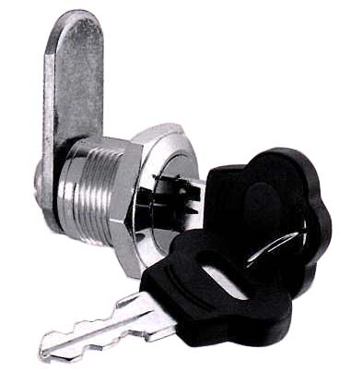

  Sizes | L1 | L2
  S | 17.8 | 24.9
  L | 30.6 | 38.4
  Fig. No. | Lock Number | Positions | Key Pulls | Turn
  1 | C628S-1 | 2 | 1 | 90 
  1 | C628L-1 | 2 | 1 | 90 
  1 | C628S-2 | 2 | 2 | 90 
  1 | C628L-2 | 2 | 2 | 90 

