C920
HIGH SECURITY CAM LOCK

DESCRIPTIONS:  - Zinc alloy die cast housing and cylinder.  - Bright chrome plated standard  - 14 tumbler, triple bitted mechanism.  - Brass keys, nickel plated.  - Key withdrawals in one position only.  - Hex nut mounted.  - 5000 combinations available.  KEY-PULL FIGURES  -Indicates Key-Pull  -Indicates No Key-Pull  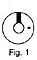 | 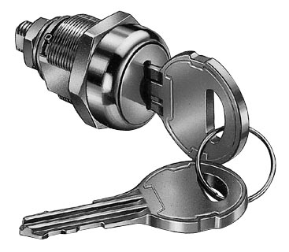

Fig. No. | Lock Number | Positions | Key Pulls | Turn
1 | C920 | 2 | 1 | 90 

