C1093
MICRO CAM LOCK

DESCRIPTIONS:  - Zinc alloy die cast housing and cylinder.  - Bright chrome plated standard.  - 5 disc tumbler mechanism.  - Brass keys, nickel plated.  - Key may be withdrawn in one or both positions.  - Various cam configurations and rotations available.  - Cam is afixed by screw.  - Hex nut or speed clip mounted.  - 30 combinations available.  KEY-PULL FIGURES  -Indicates Key-Pull  -Indicates No Key-Pull  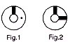 | 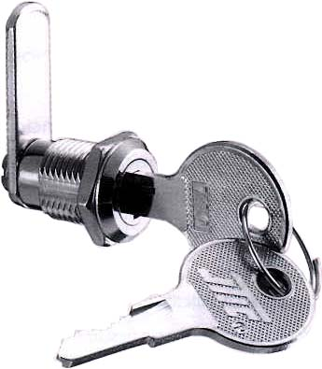

Fig. No. | Lock Number | Positions | Key Pulls | Turn
1 | C1093-1 | 2 | 1 | 90 
2 | C1093-2 | 2 | 2 | 90 

