C510Z SERIES
CAM LOCK

DESCRIPTIONS:  - C510XS brass housing and cylinder.  - C510ZSS, C510ZS, C510ZM and C510ZL zinc alloy die cast housing and cylinder.  - Bright chrome plated standard.  - 7 pin tumbler mechanism.  - Steel made tubular keys, nickel plated.  - Key may be withdrawn in one or both positions.  - 5 sizes available.  - Various cam configurations and rotations available.  - Cam is affixed by nut.  - Hex nut mounted.  - 10000 combinations available.  KEY-PULL FIGURES  -Indicates Key-Pull  -Indicates No Key-Pull  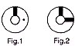 | 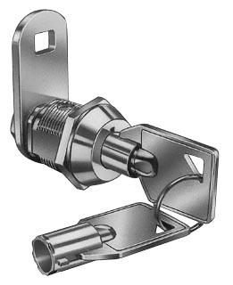

  Sizes
  XS | 9.5 | 23.3
  ZSS | 11 | 25
  ZS | 17 | 34.3
  ZM | 23 | 39.7
  ZL | 28 | 44.7
  Fig. No. | Lock Number | Positions | Key Pulls | Turn
  1 | C510XS-1 C510ZSS-1  C510ZS-1 C510ZM-1  C510ZL-1 | 2 | 1 | 90 
  2 | C510XS-2 C510ZSS-2  C510ZS-2 C510ZM-2  C510ZL-2 | 2 | 2 | 90 

