S206A
KEYLOCK SWITCH

S1096 | KEYLOCK SWITCH

DESCRIPTIONS:  - Zinc alloy die cast housing and cylinder.  - Stainless steel capped bezel.  - Bright chrome plated standard.  - 4 disc tumbler mechanism.  - Brass keys, nickel plated.  - "L" dimension 13mm standard; other dimensions available upon request.  - Dual-functioned Key Lock Switch.  - Key may be withdrawn in one or both positions.  - Silver plated contacts and terminals.  - 2 position (off-on) 2 terminals.  - Hex nut or speed clip mounted.  - 20 combinations available.  KEY-PULL FIGURES  -Off Position  -Indicates Key-Pull  -Indicates No Key-Pull  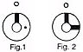 | 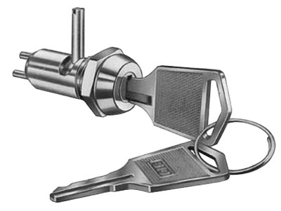

Fig. No. | Lock Number | Pole | Positions | Terminals | Key Pulls | Turn |  |  | Type
1 | S1096-1 | 1 | 2 | 2 | 1 | 90  | Off | On | SPST
2 | S1096-2 | 1 | 2 | 2 | 2 | 90  | Off | On | SPST

