S286A
KEYLOCK SWITCH

DESCRIPTIONS:  - Zinc alloy die cast housing and cylinder.  - Bright chrome plated standard.  - 5 disc tumbler mechanism.  - Reversible double-bitted brass keys, nickel plated.  - Silver plated contacts and terminals.  - 2 position (off-on) 4 terminals. (2NO 2NC)  - Hex nut or speed clip mounted.  - 150 combinations available.  KEY-PULL FIGURES  -Off Position  -Indicates Key-Pull  -Indicates No Key-Pull  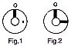 | 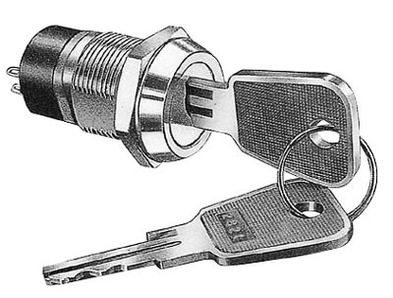

Fig. No. | Lock Number | Pole | Positions | Terminals | Key Pulls | Turn |  |  | Type
1 | S286A-1 | 2 | 2 | 4 | 1 | 90  | Off | On | DPST
2 | S286A-2 | 2 | 2 | 4 | 2 | 90  | Off | On | DPST

