C520 SERIES
CAM LOCK

DESCRIPTIONS:  - C520ZS zinc alloy die cast housing and cylinder.  - C520M and C520L brass housing and cylinder.  - Bright chrome plated standard.  - 4 pin tumbler mechanism.  - Steel made tubular keys, nickel plated.  - Key may be withdrawn in one or both positions.  - 3 sizes available.  - Various cam configurations and rotations available.  - Cam is affixed by nut.  - Hex nut mounted.  - 100 combinations available.  KEY-PULL FIGURES  -Indicates Key-Pull  -Indicates No Key-Pull  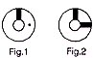 | 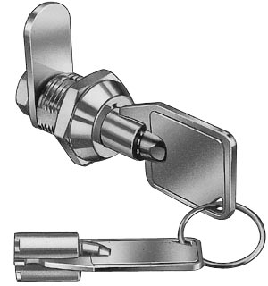

  Sizes
  ZS | 10.5 | 21.1
  M | 13 | 23.6
  L | 16 | 26.6
  Fig. No. | Lock Number | Positions | Key Pulls | Turn
  1 | C520ZS-1  C520M-1  C520L-1 | 2 | 1 | 90 
  2 | C520ZS-2  C520M-2  C520L-2 | 2 | 2 | 90 

