C626-D series
LARGE FULL SIZE FLAT CAM LOCK

DESCRIPTIONS:  - Zinc alloy die cast housing and cylinder.  - Stainless steel capped bezel with dust shutter mechanism.  - Yellow die-chromate plated standard.  - 5 disc tumbler mechanism.  - Reversible double-bitted brass keys, nickel plated.  - Key may be withdrawn in one or both positions.  - 3 sizes available.  - Various cam configurations and rotations available.  - Cam is affixed by screw or fixed.  - Hex nut or speed clip mounted.  - 100 combinations available  KEY-PULL FIGURES  -Indicates Key-Pull  -Indicates No Key-Pull  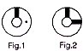 | 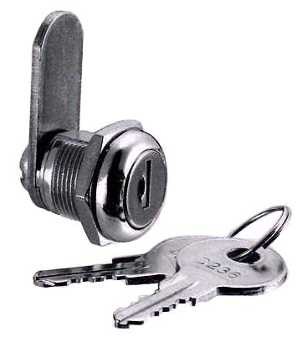

SCREW FIXED
  Sizes | L1 | L2 | L2
  S | 15.9 | 22.9 | 19.3
  M | 22.2 | 29.3 | 
  XL | 35.3 | 42.2 | 
  Fig. No. | Lock Number | Positions | Key Pulls | Turn
  1 | C626S-1 | 2 | 1 | 90 
  1 | C626M-1 | 2 | 1 | 90 
  1 | C626XL-1 | 2 | 1 | 90 
  2 | C626S-2 | 2 | 2 | 90 
  2 | C626M-2 | 2 | 2 | 90 
  2 | C626XL-2 | 2 | 2 | 90 

