C310 | CAM LOCK

DESCRIPTIONS:  - Brass housing and cylinder.  - Bright chrome plated standard.  - 7 pin tumbler mechanism.  - Steel made tubular keys, nickel plated, with plastic cover.  - Key may be withdrawn in one or both positions.  - 3 sizes available.  - Various cam configurations and rotations available.  - Cam is affixed by nut.  - Hex nut mounted.  - 10000 combinations available.  KEY-PULL FIGURES  -Indicates Key-Pull  -Indicates No Key-Pull  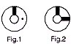 | 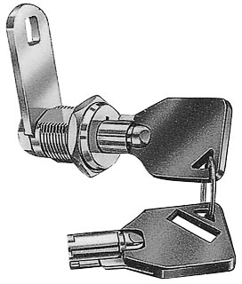

  Sizes
  S | 10.5 | 25
  M | 13 | 27.5
  L | 16 | 30.5
  Fig. No. | Lock Number | Positions | Key Pulls | Turn
  1 | C310-1 | 2 | 1 | 90 
  2 | C310-2 | 2 | 2 | 90 

