S203A S203AM
LARGE FULL SIZE FLAT SWITCH LOCK

DESCRIPTIONS:  - Zinc alloy die cast housing and cylinder.  - Bright chrome plated standard.  - 11 disc tumbler mechanism.  - Reversible double-bitted brass keys  - Key may be withdrawn in one or both positions.  - S203A 2 position (off-on) 2 spade terminals.  - S203AM 2 position (off-on) 2 spade terminals, spring loaded for momentary contact.  - Hex nut mounted.  - 5 combinations available.    SPECIFICATION  - Contact Rating: 4A 125VAC, 2A 250VAC.  - Contact Resistance: 10Milli-Ohms Max.  - Insulation Resistance: 500 Meg-Ohms Min. (500VDC)  - Dielectric Strength: 1500 VAC -1 Minute.D  KEY-PULL FIGURES  -Off Position  -Indicates Key-Pull  -Indicates No Key-Pull  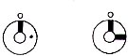 | 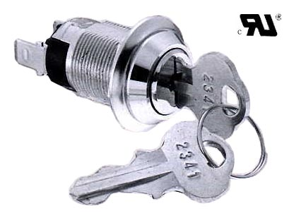

Fig. No. | Lock Number | Pole | Positions | Terminals | Key Pulls | Turn |  |  | Type
1 | S203A-1 | 1 | 2 | 2 | 1 | 90  | Off | On | SPST
2 | S203A-2 | 1 | 2 | 2 | 2 | 90  | Off | On | SPST
3 | S203AM | 1 | 2 | 2 | 1 | 90  | Off | (On) | SPST

